**GUN CONTROL**

**Do tweets that use more emotional language in respect of gun control have a higher engagement rate?**

Average engagement rate (for info, in case helpful in discussion): 1.32%, 95% CI [1.04, 1.60]

Frequency of sentiment scores with average plotted as a red vertical line:

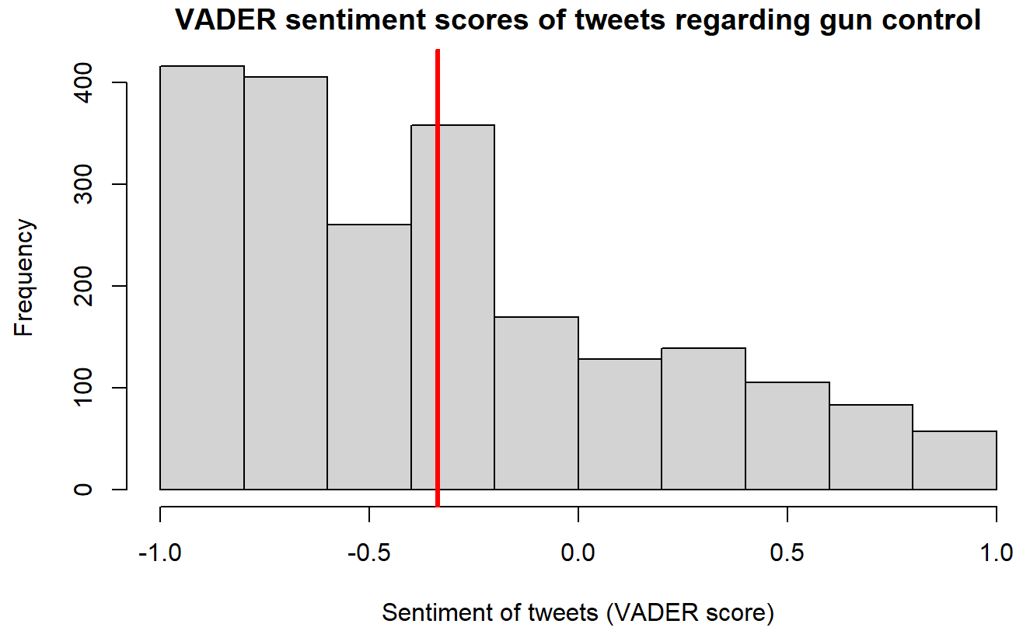

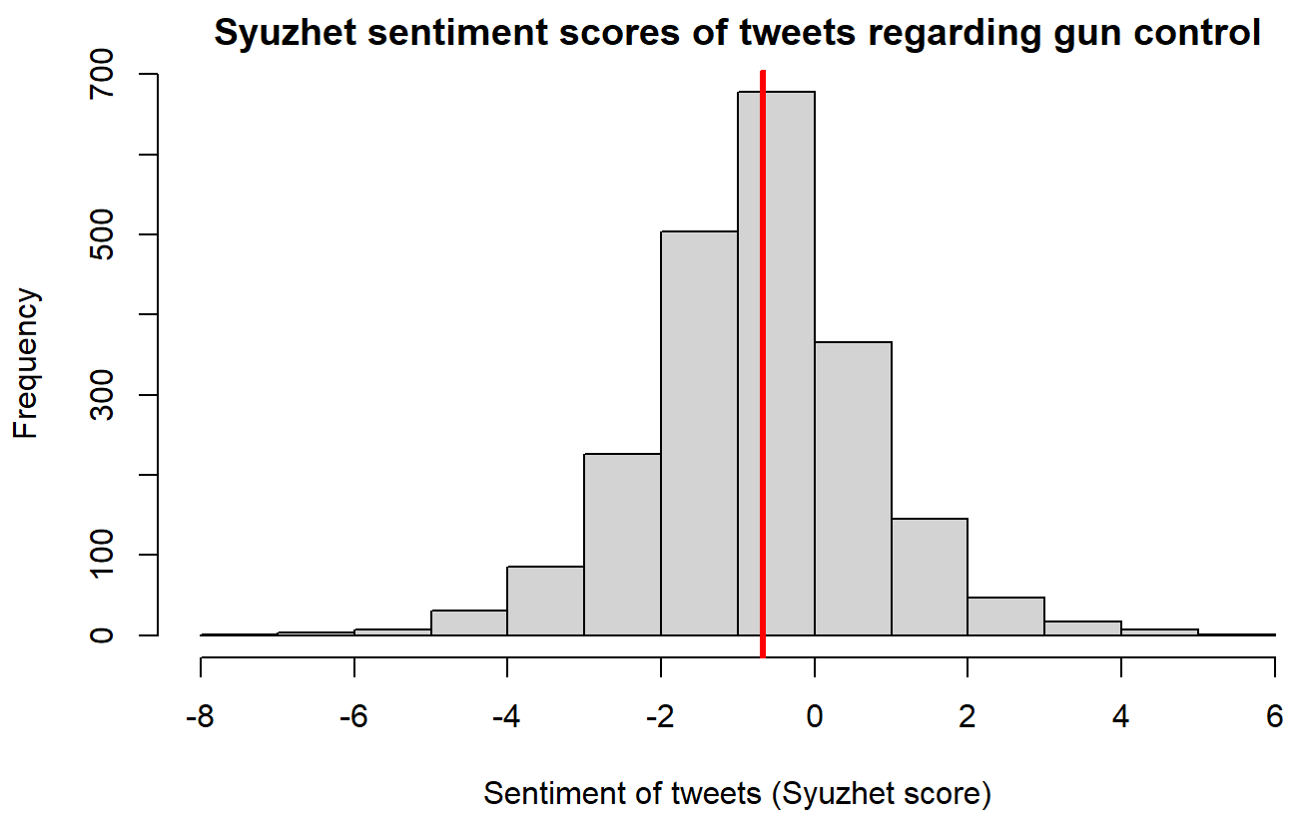

Scatter plots showing engagement rates vs sentiment scores to look for any observable relationships (NOTE: Just for the plots, but not the statistical analysis, data was filtered so that the upper limit of the 95% confidence interval was used as the max engagement rate. This is because there are some large outliers that otherwise make it difficult to see what is going on.):

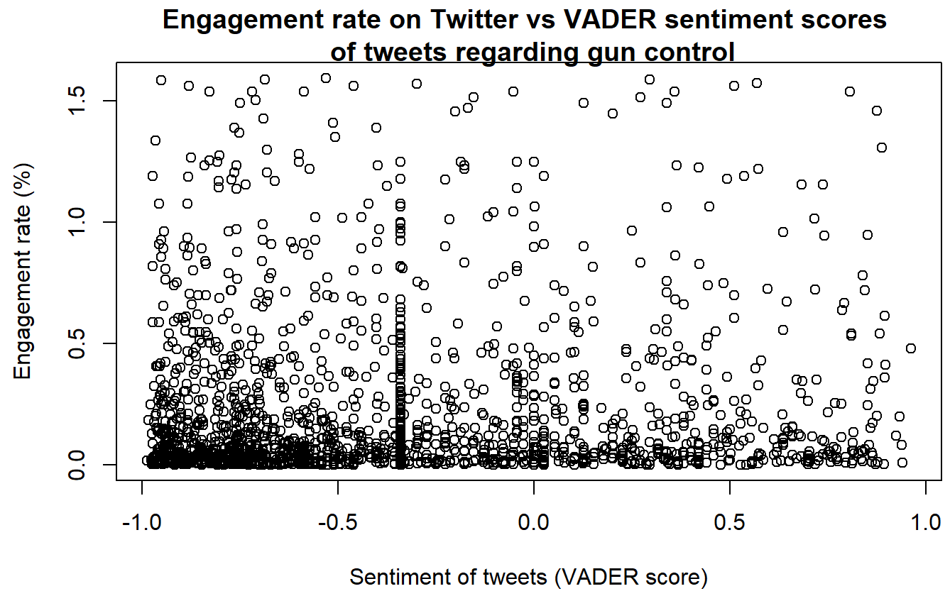

Simple linear regression was used to test if VADER sentiment scores of Tweets significantly predicted the engagement rate and no statistical significance was found (β = 3.499e-06, 95% CI [-0.00324, 0.00325], p = 0.998, adjusted R2 = -0.00047). Assumptions of the linear regression model were checked.

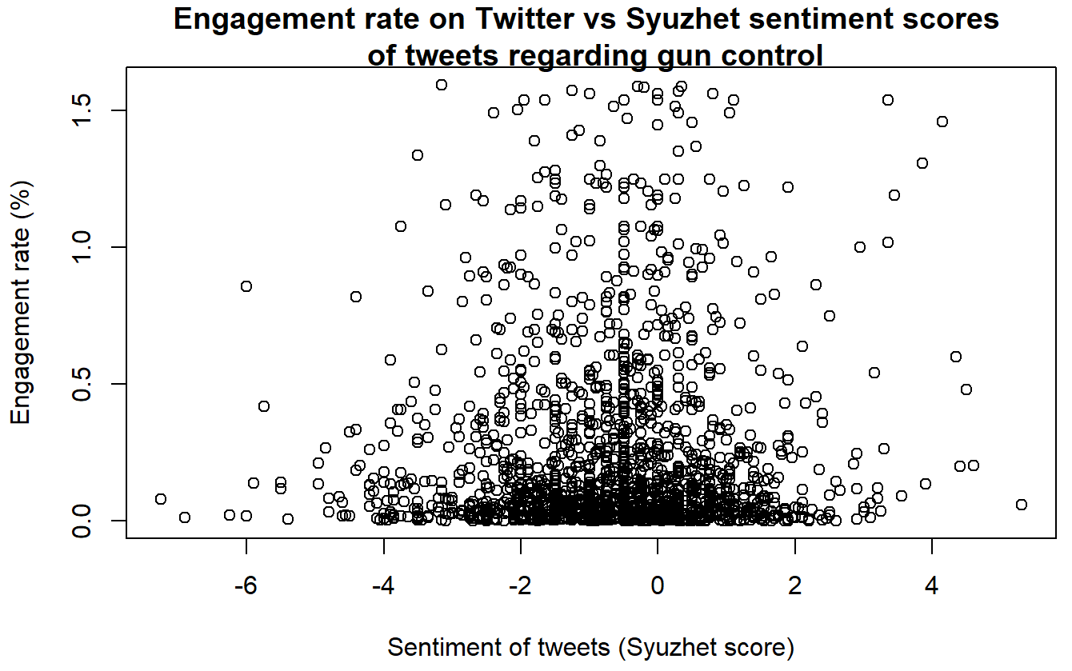

Simple linear regression was used to test if Syuzhet sentiment scores of Tweets significantly predicted the engagement rate and no statistical significance was found (β = 0.00374, 95% CI [-0.00577, 0.01325], p = 0.441, adjusted R2 = -0.00019). Assumptions of the linear regression model were checked.

We also separately looked at the relationship between engagement rates and positive and negative sentiment scores to check if there is a relationship that was not observable when the entire dataset was used (NOTE: Just for the plots, but not the statistical analysis, data was filtered so that the upper limit of the 95% confidence interval was used as the max engagement rate. This is because there are some large outliers that otherwise make it difficult to see what is going on.):

* VADER

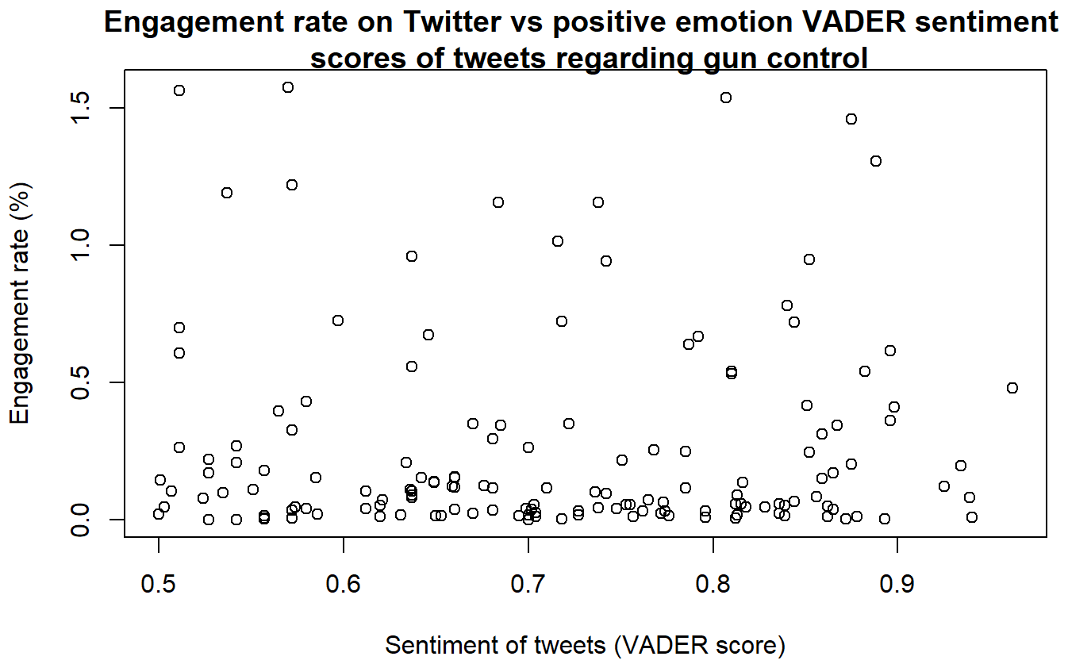

Simple linear regression was used to test if positive VADER sentiment scores of Tweets significantly predicted the engagement rate and no statistical significance was found (β = 0.00088, 95% CI [-0.00262, 0.00439], p = 0.619, adjusted R2 = -0.00413). Assumptions of the linear regression model were checked.

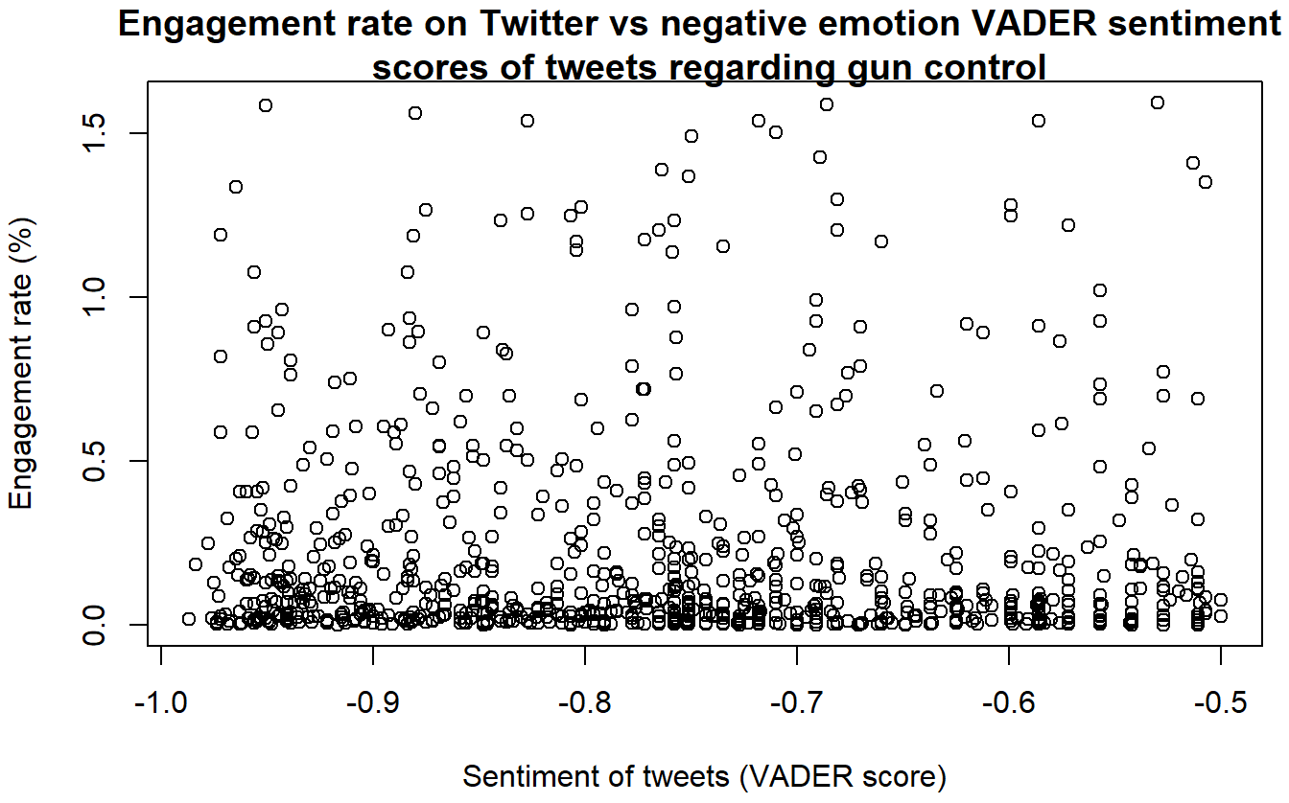

Simple linear regression was used to test if negative VADER sentiment scores of Tweets significantly predicted the engagement rate and no statistical significance was found (β = -0.00048, 95% CI [-0.00163, 0.00066], p = 0.404, adjusted R2 = -0.00031). Assumptions of the linear regression model were checked.

* Syuzhet

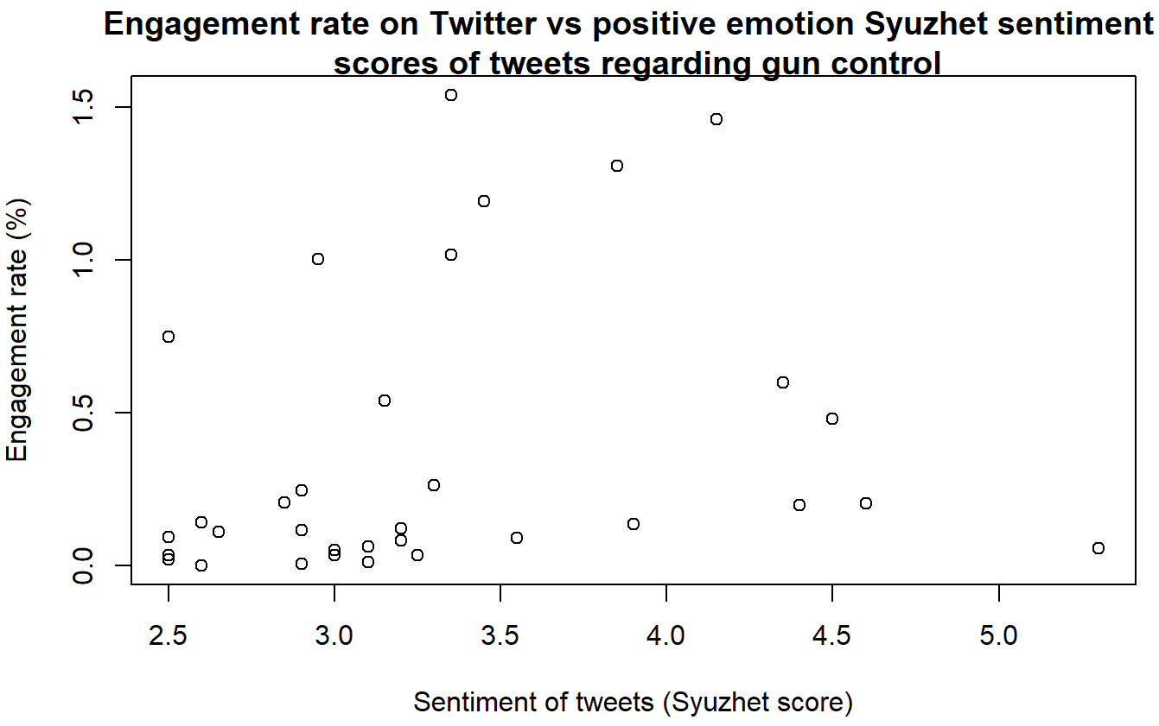

Simple linear regression was used to test if positive Syuzhet sentiment scores of Tweets significantly predicted the engagement rate and no statistical significance was found (β = -0.00075, 95% CI [-0.03601, 0.03450], p = 0.966, adjusted R2 = -0.02321). Assumptions of the linear regression model were checked.

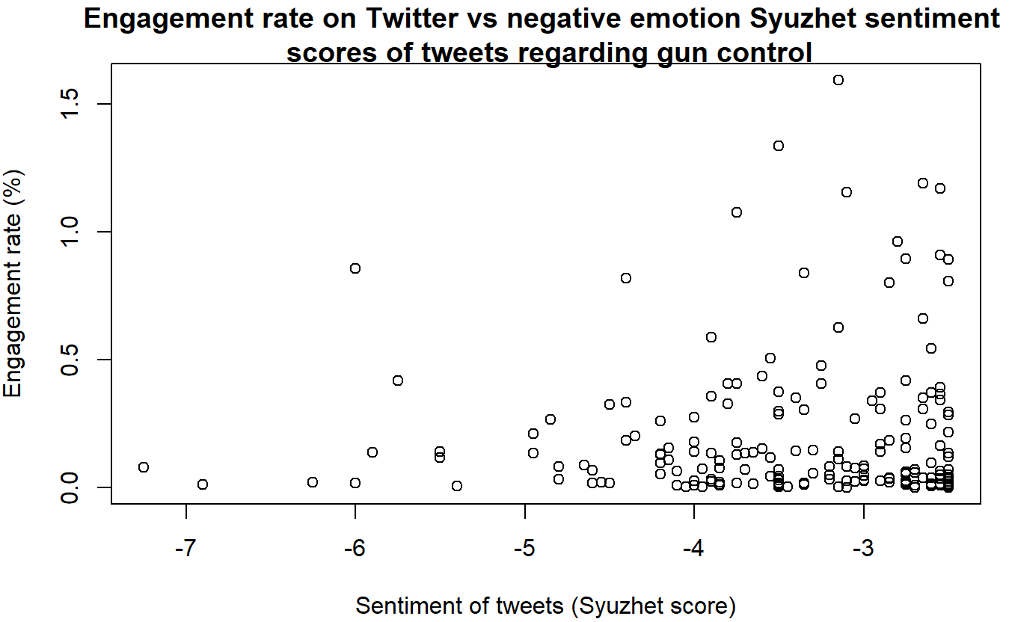

Simple linear regression was used to test if negative Syuzhet sentiment scores of Tweets significantly predicted the engagement rate and no statistical significance was found (β = -0.00132, 95% CI [-0.03278, 0.03013], p = 0.934, adjusted R2 = -0.00456). Assumptions of the linear regression model were checked.

**Is there a difference between engagement rates of tweets containing positive and negative emotional language?**

Plots of mean engagement rate showing 95% CI for three categories of sentiment (positive, neutral and negative):

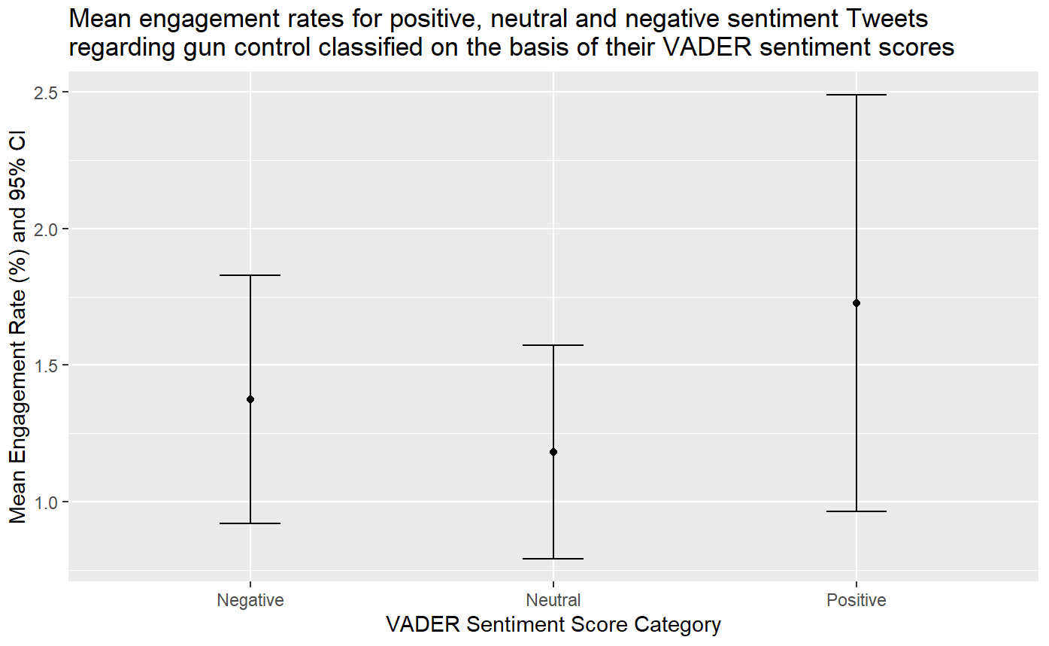

Negative = scores from -1 to -0.5; neutral = scores from -0.4 to 0.4; positive = scores from 0.5 to 1.

To determine which statistical test to perform, data was tested for normality. Engagement rates of Tweets with negative and positive VADER sentiment scores were found to have non-normal distribution using Shapiro-Wilk's test (W = 0.16569, p-value < 2.2e-16; W = 0.3446, p-value < 2.2e-16; respectively).

Wilcoxon rank-sum test was carried out to test if the mean engagement rates of Tweets with negative and positive VADER sentiment scores are significantly different from each other and the test revealed that they are significantly different at 1% significance level (W = 103891, p-value = 0.00123).

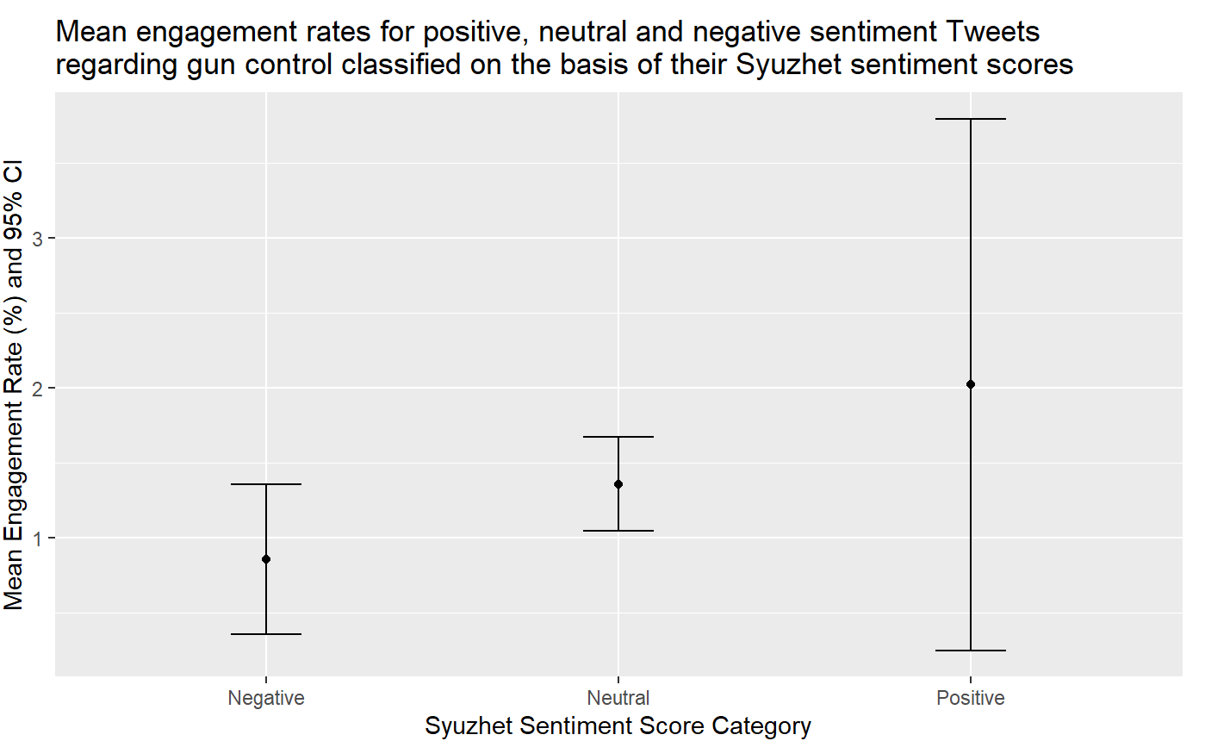

Negative = scores from -5 to -2.5; neutral = scores from -2.4 to 2.4; positive = scores from 2.5 to 5.

To determine which statistical test to perform, data was tested for normality. Engagement rates of Tweets with negative and positive Syuzhet sentiment scores were found to have non-normal distribution using Shapiro-Wilk's test (W = 0.20784, p-value < 2.2e-16; W = 0.3179, p-value = 3.605e-13; respectively).

Wilcoxon rank-sum test was carried out to test if the mean engagement rates of Tweets with negative and positive Syuzhet sentiment scores are significantly different from each other and the test revealed that they are significantly different at 0.1% significance level (W = 6752, p-value = 0.0001202).

—-----------------------------------------------------------------------

**Exploratory analysis**

Note: Retrieved 22/01/09 20:15, 7232 entries before filtering

Top 5 tweets according to engagement rate:

1. *@NoVA_Campaigns @MomsDemand The surge of new gun owners results from the constant threat of crime Americans face because of the defund-police movement and overall refusal to control crime in high-risk areas. Another factor is the continuous threat to the Second Amendment right to keep and bear arms 👍🇺🇲👍*1 retweets, 1 followers, 100% engagement rate   
   VADER score -0.945, Syuzhet score -0.65  
   Not a famous person, not a lot of followers, not informative.
2. *@SpeakerPelosi @GabbyGiffords Why is there not reasonable gun control, the Second Amendment described a militia, not a mob walking down a street or intimidating legislators in State Capitals*  
   2 retweets, 2 follower, 100% engagement   
   VADER score -0.218, Syuzhet score -1.30  
   Not a famous person, not a lot of followers, not informative.
3. *@dicostanzo_j @GovKathyHochul What about the rapes, stabbings, physical attacks, bullying, clubs, bats, that don't involve guns? Take away guns and thugs will find another way, meaning focus on the behavior/individual, not the tools. Guns make nice headlines for you and the left, but gun control doesn't work.*1 retweets, 1 followers, 100% engagement rate   
   VADER score -0.810, Syuzhet score -1.40  
   Not a famous person, not a lot of followers, not informative.
4. *#RedErin must go. Since becoming leader of the @CPC_HQ in Aug 2020, @erinotoole has remained silent on the divisive &amp; hateful rhetoric of @JustinTrudeau, he flip flopped on the carbon tax, #DefundTheCBC, gun control and has been silent on civil liberty violations during lockdowns* [*https://t.co/Qb4uOuY3K8*](https://t.co/Qb4uOuY3K8)  
   4 retweets, 7 followers, 57.14% engagement rate   
   VADER score -0.681. Syuzhet score -0.55  
   Quotes a user with 165k followers and mentions a number of high profile users.
5. *@GovKathyHochul In a recent post you spoke on gun control. I fought to the ground and apprehended an armed felon possessing a stolen handgun IN A STATE PARK. Yup.. that happens. And now @ErikKulleseid wants kids patrolling our state parks?! An insult, and a joke. @pbanystate.*10 retweets, 19 followers, 52.63% engagement rate   
   VADER score -0.852, Syuzhet score -2.15

Interestingly, the 3 of the top 4 tweets with lowest engagement rates are from the same user - ABC13 Houston, a news channel. All have neutral sentiment but low engagement rates (low rates are not just due to time of posting and data retrieval).